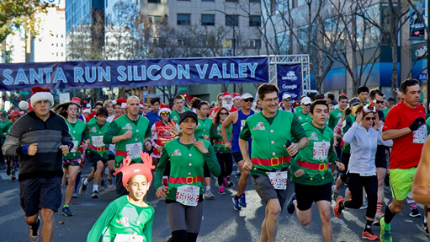

**Contact:**

Kimberly Ellis, SVP Comms & Marketing  
[kellis@svlg.org](mailto:kellis@svlg.org) | 408-501-7853  
Pam Kelly, Comms Mgr.  
[pkelly@svlg.org](mailto:pkelly@svlg.org)|408-483-2410

**“Ho, Ho, Ho” - Santa Spectacle Brings Merry and Nice to Downtown San Jose  
 Google Santa Run Silicon Valley**

**SAN JOSE, CA.** –The Grinch may be welcome in the movie theaters but less so at this year’s Google Santa Run Silicon Valley. This morning more than 4,000 merry-makers are driving him out of town as they line up for the 7thAnnual Santa Run 5K this Sunday, December 16th dressed as Mr. & Mrs. Claus, elves and everything in between. The “Grinch”, Santa Clara County Tax Assessor Larry Stone, and his sleek ride will lead runners, joggers, and walkers on a merry little chase weaving through downtown San Jose before finishing at Christmas in Park where the naughty and nice are served cookies and milk under a blizzard of snow before receiving a finisher medal and a race t-shirt.

Race participants are encouraged to dress in character as Santa Claus, Mrs. Claus, the Grinch, reindeer, elves, dreidel, menorah, ornaments, trees and candlesticks and participate in the costume contest before the race in front of Umpqua Bank on Santa Clara Street. Categories include Best Sleigh, Best Group Costume and, of course, Best Santa. This 5K Run/Walk is a fun, festive and safe alternative for families and individuals alike. There is also a Kids Reindeer Dash (ages 2-7) for the little tykes. Register today at SantaRunSV.com. Media interested in covering the event can RSVP with Kimberly Ellis at [kellis@svlg.org](mailto:kellis@svlg.org) or (408) 501-7853 or Pam Kelly at [pkelly@svlg.org](mailto:pkelly@svlg.org) or (408) 483-2410.

Founded and directed by the Silicon Valley Leadership Group Foundation, all the run’s profits are donated to three local non-profits: Christmas in the Park, Downtown Ice, and Reading Partners.

**Where**:

Santa Run Silicon Valley

225 West Santa Clara St.

Race finish at the corner of Park & South Market (next to Tech Museum)

**Who:**

Carl Guardino, Exec. Director of Silicon Valley Leadership Group Foundation

San Jose Mayor Sam Liccardo

“The Grinch” County Assessor Larry Stone

**When**:

Sunday, December 16

Kids Reindeer Dash - 2:40 pm

Santa Run 5k - 3:30 pm (finishers arrive in Christmas in the Park approx. 4:00-4:30 pm)

**###**

**About the Google “Santa Run Silicon Valley”**  
The Google “Santa Run Silicon Valley” 5K walk/run has become a new holiday tradition in Silicon Valley raising $475,000 for Christmas in the Park and Downtown Ice since 2012, along with collecting 3 ,500 children’s books for Reading Partners.

With public funding for Christmas in the Park and Downtown Ice rapidly declining, the Silicon Valley Leadership Group Foundation – in partnership with former Mayor Chuck Reed and San Jose Mayor Sam Liccardo – launched the Google “Santa Run Silicon Valley” in 2012 to raise funds to preserve these two holiday traditions.

**About the Silicon Valley Leadership Group Foundation**  
The purpose of the Silicon Valley Leadership Group Foundation is to help improve the quality of life in the Silicon Valley region through the provision of funding for food, clothing, shelter, medical care, education and other necessities of life. It focuses on providing financial and promotional assistance to charities, business and community leaders, scholars or other groups that support its mission.